Tazmeen Fazlani
190905534

Computer Networks Lab 2

Sample Program
Server Side program file called “sserver.c”:
//Server Program
#include <stdio.h>
#include <stdlib.h>
#include <unistd.h>
#include <errno.h>
#include <string.h>
#include <sys/types.h>
#include <sys/socket.h>
#include <netinet/in.h>
#include <netdb.h>
#include <arpa/inet.h>
#include <sys/wait.h>
#include <signal.h>
int main()
{
int sd,nd,n,len,reult;
struct sockaddr_in seraddress, cliaddr;
char buf[256];
sd=socket(AF_INET, SOCK_STREAM, 0);
seraddress.sin_family=AF_INET;
seraddress.sin_addr.s_addr=INADDR_ANY;
seraddress.sin_port=htons(10200);
bind(sd,(struct sockaddr*)&seraddress,sizeof(seraddress));
listen(sd,5);
len=sizeof(cliaddr);
while(1)
{
nd=accept(sd,(struct sockaddr*)&cliaddr,&len);
if (fork()==0){
close(sd);
int pid = getpid();
n=read(nd,buf,sizeof(buf));
printf("message from client %s and pid is: %d\n",buf,pid);
getchar();}
close(nd);
}
}
Client Side program file called “sclient.c”:
//Client program
#include <stdio.h>
#include <stdlib.h>
#include <unistd.h>
#include <errno.h>
#include <string.h>
#include <sys/types.h>
#include <sys/socket.h>
#include <netinet/in.h>
#include <netdb.h>
#include <arpa/inet.h>
#include <sys/wait.h>
#include <signal.h>
int main()
{
int sd,nd,n,len,reult,n1;
struct sockaddr_in seraddress, cliaddr;
char buf[256], buf1[256];
sd=socket(AF_INET, SOCK_STREAM,0);
seraddress.sin_family=AF_INET;
seraddress.sin_addr.s_addr=INADDR_ANY;
seraddress.sin_port=htons(10200);
len=sizeof(seraddress);
connect(sd,(struct sockaddr*)&seraddress,len);
printf("enter the message to send \n");
gets(buf);
n=write(sd,buf,strlen(buf));
n1=read(sd,buf1,sizeof(buf1));
printf("message from ser %s\n",buf1);
getchar();
}

OUTPUT
Server side
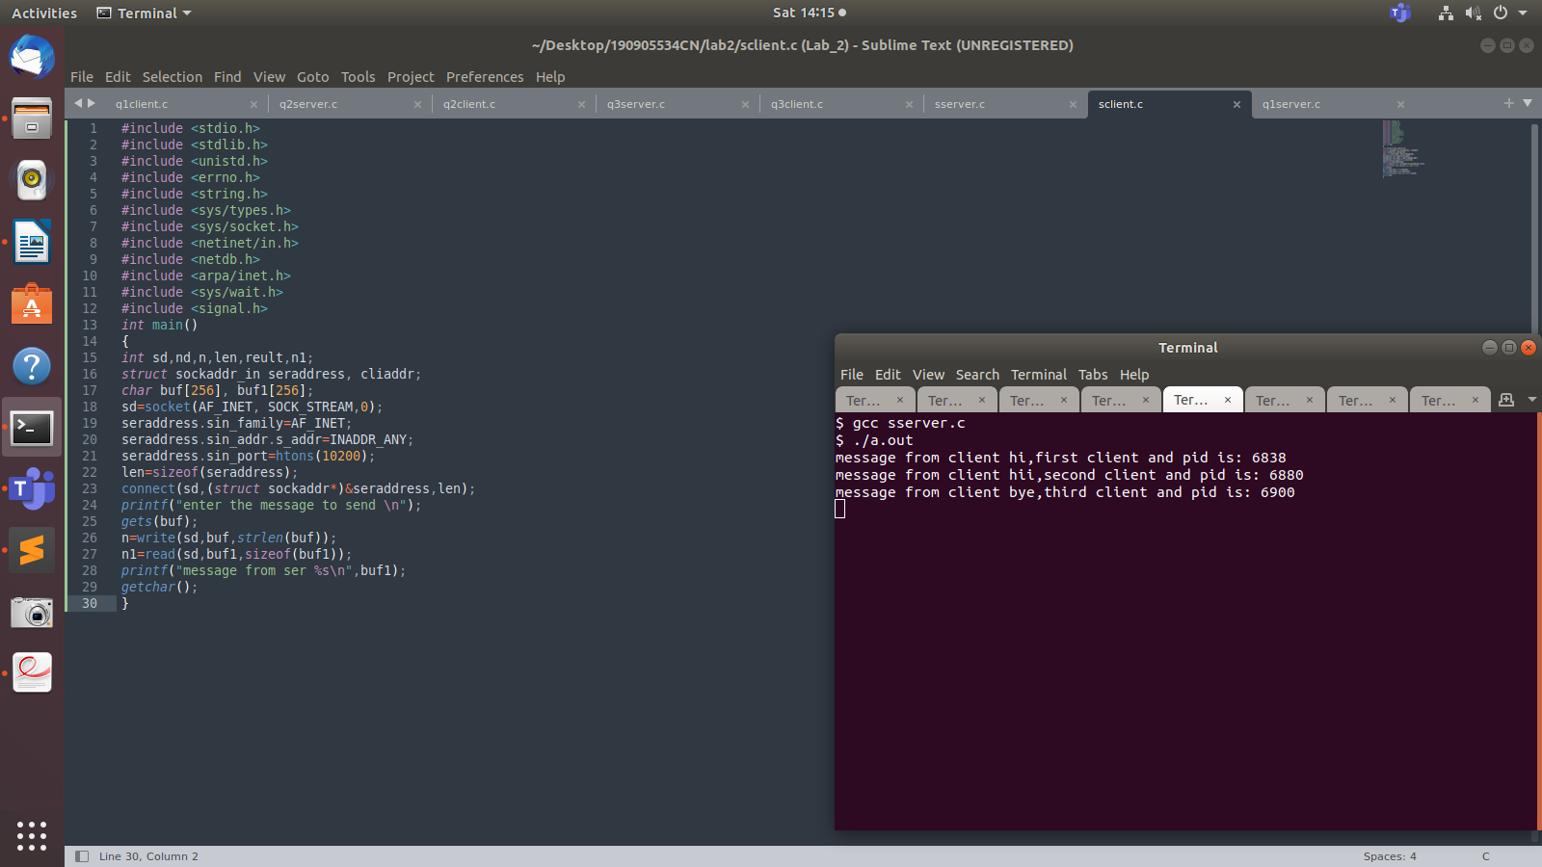

Client side:
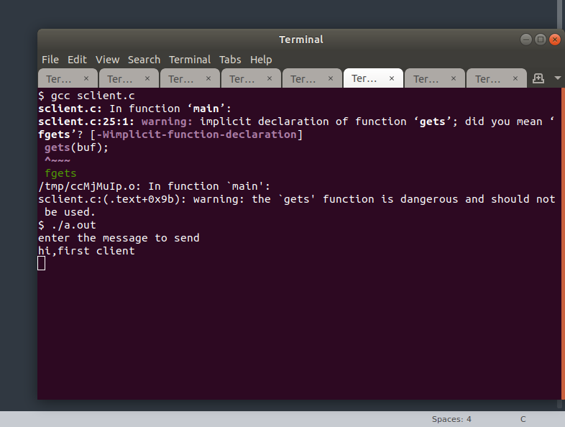
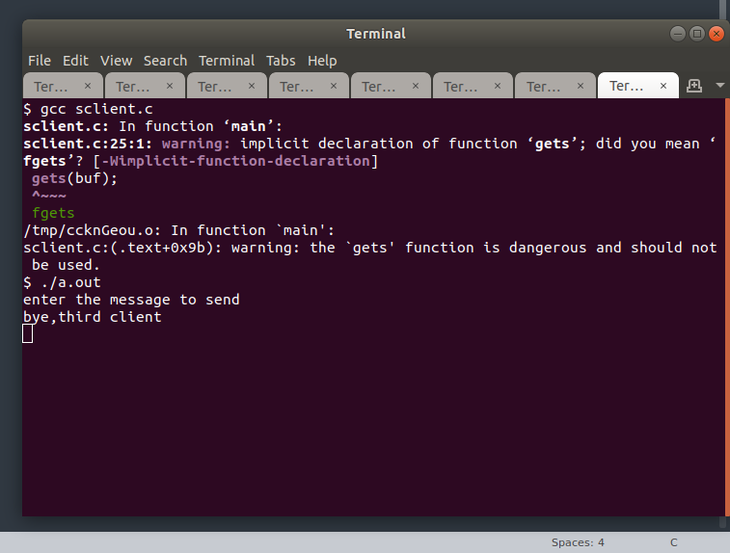

1. Write a TCP concurrent client server program where server accepts integer array from
client and sorts it and returns it to the client along with process id.

Server Side program file called “q1server.c”:

//Server program
#include <stdio.h>
#include <stdlib.h>
#include <unistd.h>
#include <errno.h>
#include <string.h>
#include <sys/types.h>
#include <sys/socket.h>
#include <netinet/in.h>
#include <netdb.h>
#include <arpa/inet.h>
#include <sys/wait.h>
#include <signal.h>

int cmpfunc(const void *a, const void *b){
return (*(int *)a - *(int *)b);
}

int main(){
int sd, nd, len, n;
struct sockaddr_in seraddress, cliaddr;
int arr[20];
int arr_size = 0;

sd = socket(AF_INET, SOCK_STREAM, 0);

seraddress.sin_family = AF_INET;

seraddress.sin_addr.s_addr = INADDR_ANY;

seraddress.sin_port = htons(10200);

bind(sd, (struct sockaddr *)&seraddress, sizeof(seraddress));

listen(sd, 5);

len = sizeof(cliaddr);

while (1){
nd = accept(sd, (struct sockaddr *)&cliaddr, &len);
printf("Connected to client");

if (fork() == 0){
close(sd);
int pid = getpid();
n = read(nd, &arr_size, sizeof(int));
n = read(nd, arr, arr_size * sizeof(int));

//Sort
qsort(arr, arr_size, sizeof(int), cmpfunc);

n = write(nd, &pid, sizeof(int));
n = write(nd, arr, arr_size * sizeof(int));

getchar();

close(nd);
}
}
}

Client Side program file called “q1client.c”:

#include <stdio.h>
#include <stdlib.h>
#include <unistd.h>
#include <errno.h>
#include <string.h>
#include <sys/types.h>
#include <sys/socket.h>
#include <netinet/in.h>
#include <netdb.h>
#include <arpa/inet.h>
#include <sys/wait.h>
#include <signal.h>

int main(){
int sd, len, n;
struct sockaddr_in seraddress, cliaddr;
int arr[20];
int arr_size, pid;

sd = socket(AF_INET, SOCK_STREAM, 0);
seraddress.sin_family = AF_INET;
seraddress.sin_addr.s_addr = INADDR_ANY;
seraddress.sin_port = htons(10200);

len = sizeof(seraddress);
connect(sd, (struct sockaddr *)&seraddress, len);

printf("Enter number of elements: \n");
scanf("%d", &arr_size);
printf("Enter elements: \n");

for (int i = 0; i < arr_size; i++){
scanf("%d", &arr[i]);
}

n = write(sd, &arr_size, sizeof(int));
n = write(sd, arr, arr_size * sizeof(int));
n = read(sd, &pid, sizeof(int));
n = read(sd, arr, arr_size * sizeof(int));

printf("\nSorted array: ");
for (int i = 0; i < arr_size; i++){
printf("%d ", arr[i]);
}

printf("\nProcess ID: %d\n", pid);

getchar();
}

Output:

Server side terminal:
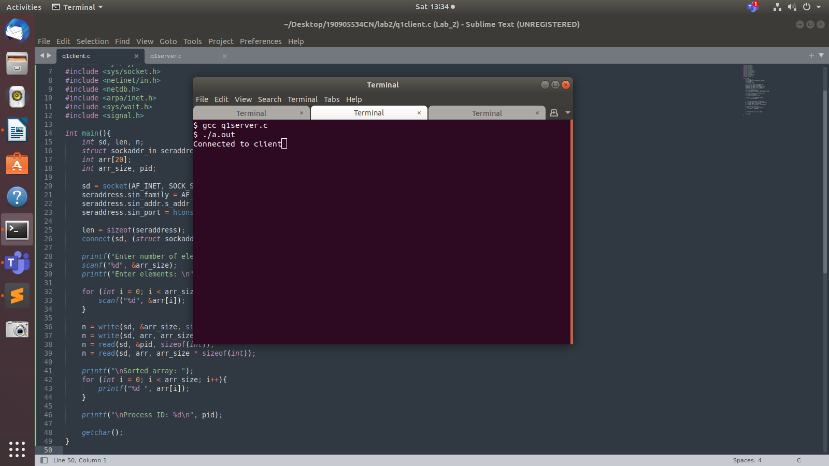

Client side terminal:

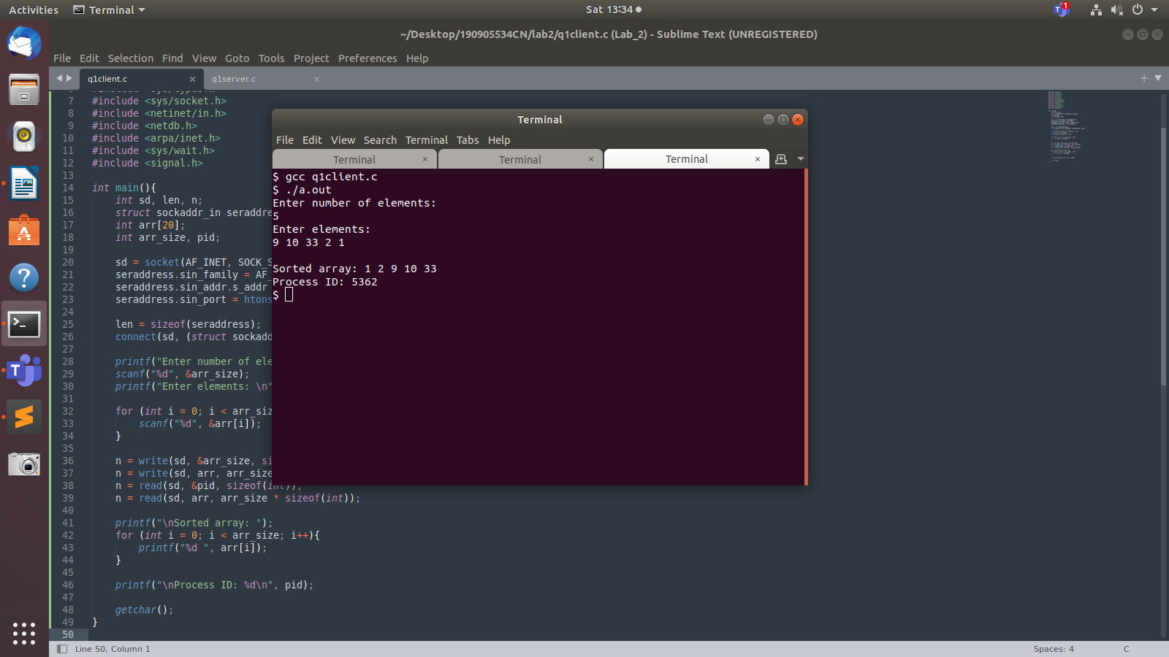

2. Implement concurrent Remote Math Server to perform arithmetic operations in the
server and display the result at the client. The client accepts two integers and an
operator from the user and sends it to the server. The server then receives integers and
operator. The server will performs the operation on integers and sends result back to
the client which is displayed on the client screen. Then both the processes terminate.

Server Side program file called “q2server.c”:
#include <stdio.h>
#include <stdlib.h>
#include <sys/types.h>
#include <sys/socket.h>
#include <arpa/inet.h>
#include <netinet/in.h>
#include <unistd.h>
#define PORT 5000

int calc(int a, int b, char operator)
{
switch(operator)
{
case '+':
return a + b;
break;
case '-':
return a - b;
break;
case '/':
return a / b;
break;
case '*':
return a * b;
break;
default:
return 0;
break;
}
}

void servfunc(int sockfd, struct sockaddr_in server_address)
{
struct sockaddr_in client_address;
int clientfd, a, b, res, size = sizeof(client_address);
char op;
while (1)
{
clientfd = accept(sockfd, (struct sockaddr *)&client_address, &size);
if (fork() == 0)
{
//in child process
printf("Child process created with clientfd %d\n", clientfd);
close(sockfd);
read(clientfd, (int *)&a, sizeof(int));
read(clientfd, (int *)&b, sizeof(int));
read(clientfd, (char *)&op, sizeof(char));
res = calc(a, b, op);
write(clientfd, (int *)&res, sizeof(int));
close(clientfd);
printf("Child process terminated with clientfd %d\n", clientfd);
exit(0);
}
else
close(clientfd); // parent process
}
printf("Server Closing!\n");
}

int main()
{
int sockfd;
struct sockaddr_in server_address;
bzero(&server_address, sizeof(server_address));
server_address.sin_family = AF_INET;
server_address.sin_port = htons(PORT);
server_address.sin_addr.s_addr = htonl(INADDR_ANY);
sockfd = socket(AF_INET, SOCK_STREAM, 0);
int res = bind(sockfd, (struct sockaddr *)&server_address, sizeof(server_address));
if(res < 0)
{
printf("Server unable to bind\n");
exit(0);
}
else
printf("Server bound successfully\n");
res = listen(sockfd, 2);
if(res < 0)
{
printf("Server unable to listne\n");
exit(0);
}
else
printf("Server listening successfully\n");
servfunc(sockfd, server_address);
close(sockfd);
}

Client Side program file called “q2client.c”:

#include <sys/types.h>
#include <sys/socket.h>
#include <stdio.h>
#include <netinet/in.h>
#include <arpa/inet.h>
#include <unistd.h>
#include <stdlib.h>
#define PORT 5000

void clifunc(int sockfd)
{
printf("I am a client and my name is Ayush Goyal.\n");
int a, b;
char c;
printf("Enter the expression as you would on a Calculator: \n");
scanf("%d%c%d", &a, &c, &b);
write(sockfd, (int *)&a, sizeof(int));
write(sockfd, (int *)&b, sizeof(int));
write(sockfd, (char *)&c, sizeof(char));
int res;
read(sockfd, (int *)&res, sizeof(int));
printf("%d %c %d = %d\n", a, c, b, res);
printf("Client Closing!\n");
}

int main(int argc, char const *argv[])
{
int sockfd;
int len;
struct sockaddr_in server_address;
int result;
char ch;
sockfd = socket(AF_INET, SOCK_STREAM, 0);
bzero(&server_address, sizeof(server_address));
server_address.sin_family = AF_INET;
server_address.sin_port = htons(PORT);
server_address.sin_addr.s_addr = htonl(INADDR_ANY);
len = sizeof(server_address);
result = connect(sockfd, (struct sockaddr *)&server_address, len);
if(result == -1)
{
printf("Connection Error Occured!\n");
exit(0);
}
clifunc(sockfd);
close(sockfd);
}
Output:

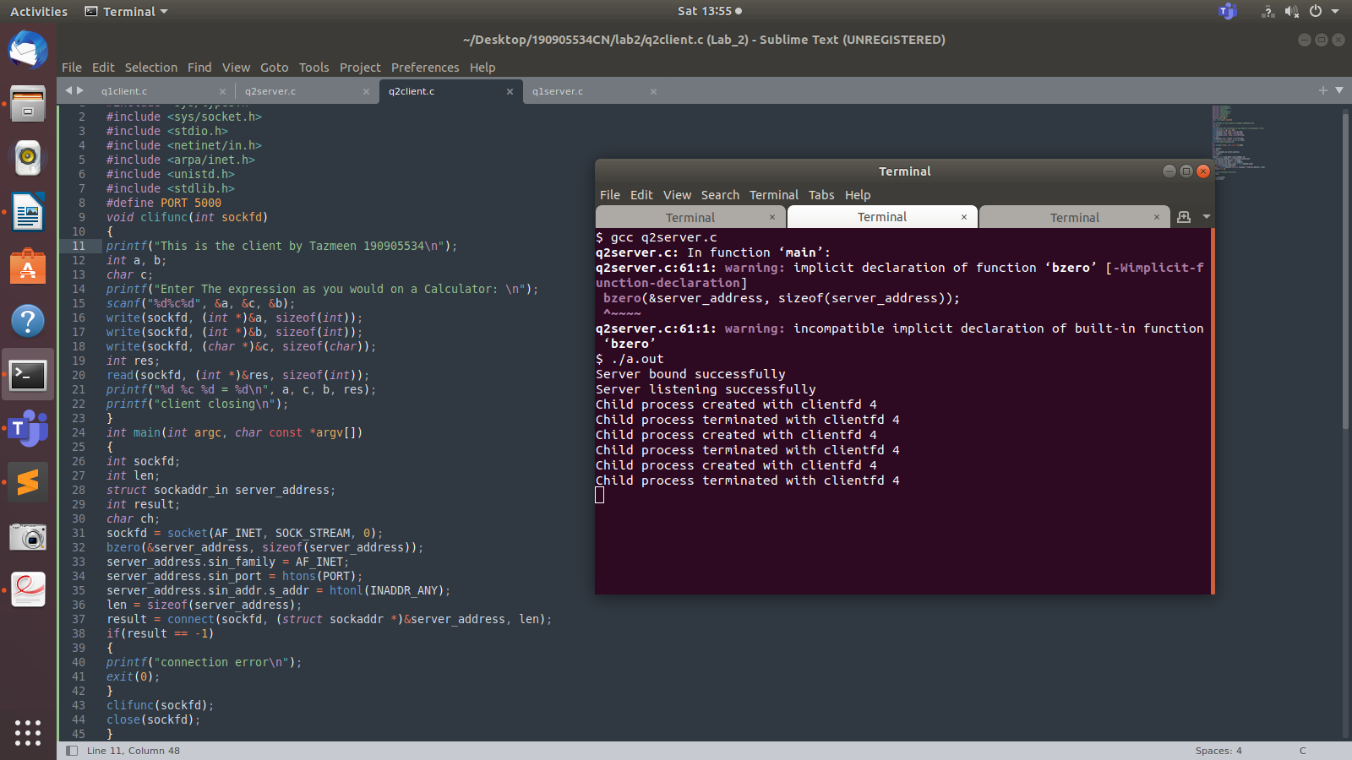
Server side terminal:

Client side terminal:

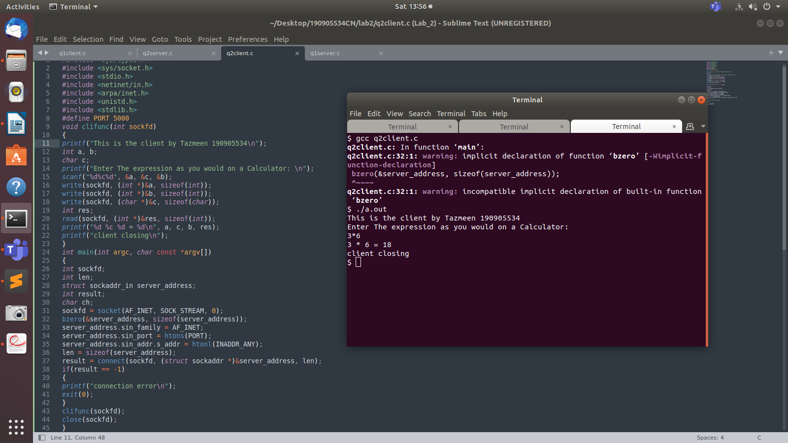

3. Implement simple TCP daytime server using fork.

Server Side program file called “q3server.c”:

#include<stdio.h>
#include<netdb.h>
#include<netinet/in.h>
#include<stdlib.h>
#include<string.h>
#include<sys/socket.h>
#include <sys/types.h>
#define MAX 100
#define PORT 1234
#define SA struct sockaddr
#include <time.h>
void servfunc(int sockfd)
{
char buff[MAX];
int n;
for (;;)
{
bzero(buff, MAX);
read(sockfd, buff, sizeof(buff));
if (strncmp("time", buff, 4) == 0)
{
time_t time_now;
time(&time_now);
strcpy(buff, asctime(localtime(&time_now)));
}
write(sockfd, buff, sizeof(buff));
if (strncmp("exit", buff, 4)==0)
{
break;
}
}}
int main()
{
int sockfd, connfd, len;
struct sockaddr_in servaddr, cli;
sockfd = socket(AF_INET, SOCK_STREAM, 0);
if (sockfd == -1)
{
printf("socket creation failed...\n");
exit(0);
}
else
printf("Socket successfully created..\n");
bzero(&servaddr, sizeof(servaddr));
servaddr.sin_family = AF_INET;
servaddr.sin_addr.s_addr = htonl(INADDR_ANY);
servaddr.sin_port = htons(PORT);
if ((bind(sockfd, (SA*)&servaddr, sizeof(servaddr))) != 0)
{
printf("socket bind failed...\n");
exit(0);
}
else
printf("Socket successfully binded..\n");
if ((listen(sockfd, 5)) != 0)
{
printf("Listen failed...\n");
exit(0);
}
else
printf("Server listening..\n");
len = sizeof(cli);
connfd = accept(sockfd, (SA*)&cli, &len);
if(fork()==0)
{
if (connfd < 0)
{
printf("server acccept failed...\n");
exit(0);
}
else
printf("server acccept the client...\n");
servfunc(connfd);
}
else
{
close(connfd);
}
}

Client Side program file called “q3client.c”:
#include<netdb.h>
#include <stdio.h>
#include <stdlib.h>
#include <string.h>
#include <sys/socket.h>
#define MAX 100
#define PORT 1234
#define SA struct sockaddr
void clifunc(int sockfd)
{
char buff[MAX];
int n;
for (;;)
{
bzero(buff, sizeof(buff));
printf("Enter the string : ");
n = 0;
while ((buff[n++] = getchar()) != '\n');
write(sockfd, buff, sizeof(buff));
bzero(buff, sizeof(buff));
read(sockfd, buff, sizeof(buff));
printf("From Server : %s", buff);
if ((strncmp(buff, "exit", 4)) == 0)
{
printf("Client Exit...\n");
break;
}
}}
int main()
{
int sockfd, connfd;
struct sockaddr_in servaddr, cli;
sockfd = socket(AF_INET, SOCK_STREAM, 0);
if (sockfd == -1)
{
printf("socket creation failed...\n");
exit(0);
}
else
printf("Socket successfully created..\n");
bzero(&servaddr, sizeof(servaddr));
servaddr.sin_family = AF_INET;
servaddr.sin_addr.s_addr = inet_addr("127.0.0.1");
servaddr.sin_port = htons(PORT);
if (connect(sockfd, (SA*)&servaddr, sizeof(servaddr)) != 0)
{
printf("connection with the server failed...\n");
exit(0);
}
else
printf("connected to the server..\n");
clifunc(sockfd);
close(sockfd);
}

Output:
Server side terminal:
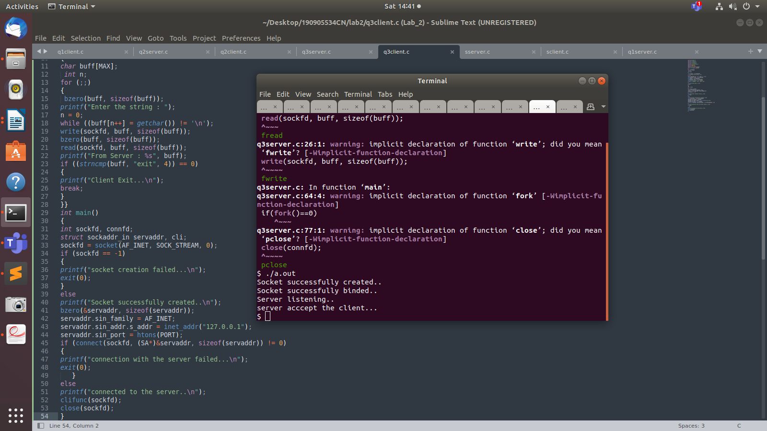

Client side terminal:

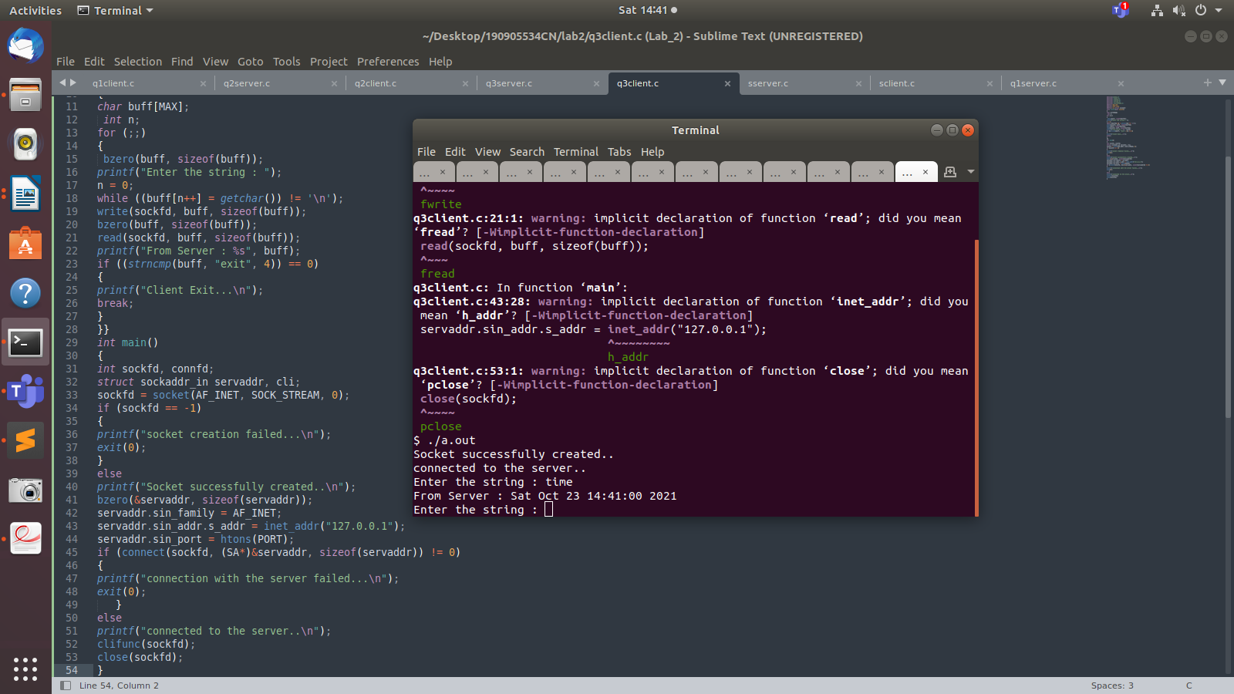

THE END

